Introduction to Networking
Networking is the process of connecting computers and other devices together so they can communicate, share data, and resources.
Networking basics
Routing: Routing is the process of sending data from one network to another, deciding the best path for it to travel.
🧭 Routing = Finding the best route for data to reach its destination.
IP addresses
To properly route your messages to a location, you need an address. That is IP address. An IP address (Internet Protocol address) is a unique number assigned to every device connected to a network.
It’s called 32 bit because you have 32 digits.
IPv4 notation
You usually don’t see an IP address in binary form; it’s shown in decimal format as an IPv4 address.
An IPv4 address, for example, 192.168.1.30 is converted from four groups of eight bits.
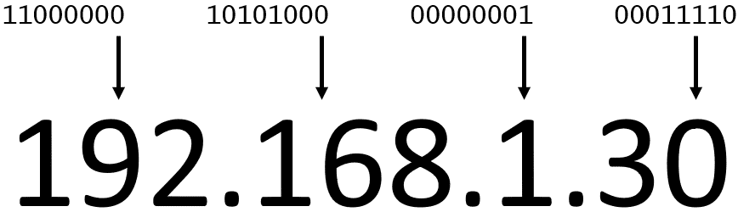
the 32 bits are grouped into groups of 8 bits, also called octets. Each of these groups is converted into decimal format separated by a period.
CIDR(Classless Inter Domain Routing) notation
CIDR notation is a compressed way of representing a range of IP addresses.
Eg:

In this example, the first 24 bits of the IP address are fixed. The rest (the last 8 bits) are flexible.
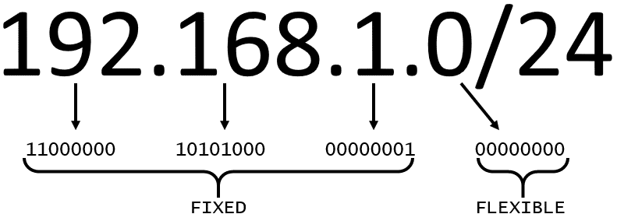
Resources
(opens in a new tab)For more information, see the following resources:
- External website: Stanford: Introduction to Computer Networking(opens in a new tab)
- AWS user guide: How Amazon VPC Works(opens in a new tab)
- External website: Wikipedia: Classless Inter-Domain Routing(opens in a new tab)
- External website: CIDR.xyz: An interactive IP Address and CIDR Range Visual

